The name of my super cool degree project
Nicholas Snow Mattsson

Degree Project FSU24D
Medieinstitutet

Instructions

The point of this document is to plan your project in detail, before you start working on it. This is to ensure that you meet the requirements for the project.

Yes, the document must be written in English.

You should spend approximately a week of working time on breaking down your project into actionable items, so reserve enough time to go through the sections in this document. Don’t attempt to do it all at once, and not 10 minutes before the deadline.

Your planning must be approved by your instructor before you start the project.

The more detailed you are, the more likely you are to succeed with your degree project.

More effort and thought during the planning phase means less mistakes and redos during the project timeframe.

The degree project is six weeks, and those weeks should be spent doing, not planning. Thus, the ambition level of your project should match the work effort of six weeks full-time doing.

This document should be your tool to use as a checkpoint for you being on track, as well as a document to validate the outcome of your project and serve as a basis for your grade.

Planning is key.

Changes during the project are of course OK - unexpected things happen and the architecture changes, but ad-hoc changes should be the exception, not the rule.

You will use this same template to report the results of your degree project, so the extensive effort you put in now will be “saved” at the end of the project. Save this in an editable version!

Table of Contents

Project idea summary 3
Application flow 3
Purpose 3
Target audience 3
Goal 3
Activity and time plan 3
Site map/function analysis/technical breakdown 4
Database structure 4
User stories x 5 4
Persona 1: Experienced user (just an example) 5
Persona 2: Some other user type 5
Test plan 5
Tech stack 5
References 6
Final check before handing in your project description 6

Project idea summary
Summarize your project idea in 3-5 sentences for an overview.

My project will be a music theory application on the web. It will consist of various games to expand and test the users knowledge on music theory. Users will also be able to log in in order to track their score.

Application flow
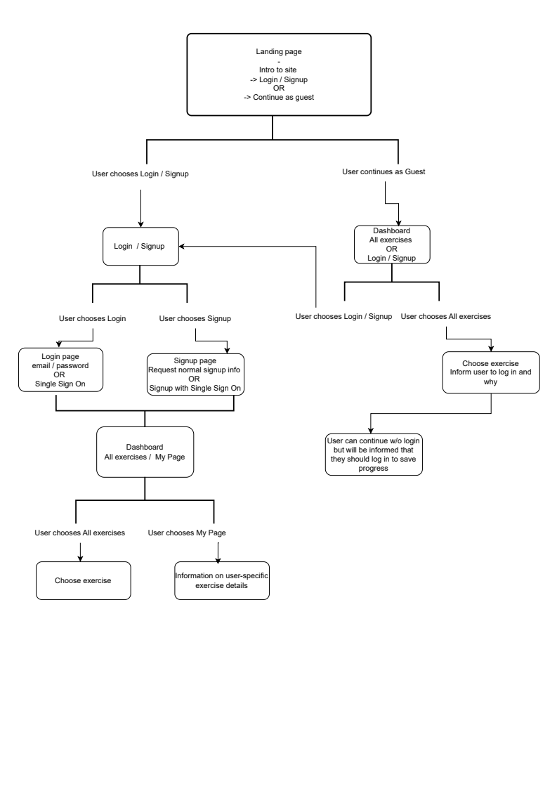

Purpose
Describe why you came up with the idea and why it’s relevant.

Describe what kind of value your project will bring.

I came up with this idea based on my own desire for a music theory application featuring the specific exercises I have designed. While there are numerous music theory websites and applications available, this project is relevant because it offers unique exercises not found in other platforms.

My project will provide value by giving users a practical and interactive way to learn and practice music theory. In addition to the exercises, it will supply resources for users to explore the specific theoretical concepts they are working on. The project will combine immediate feedback and a way to track progress, which will create a more effective learning environment which motivates the user to progress.

Target audience
Who is your target audience and/or group? Why are they interested?
My target audience consists mainly of musicians or anyone interested in learning music theory. Since the exercises build upon previous knowledge, users should have at least a basic grasp of music theory concepts. The application is valuable to this audience because it helps strengthen their theoretical skills and improves their ability to quickly analyze and apply music theory.

Goal
What is the expected outcome in 6 weeks?
How is the product/project expected to be used by the target audience?
In 6 weeks the expected outcome is an application with at least five different exercises where a user can log in, check their progress for various exercises and

Activity and time plan
Break down your project into actionable steps and define scopes for each of the three sprints.

Your planning should be detailed enough so that it’s clear that you will manage to complete the project within the given timeframe, but you don’t have to estimate each individual task at this point. However - the more detailed, the more likely you are to be successful.

- Break down your project into sprint issues/tasks, and give those a rough story point estimation.
1 Story Point (SP) ≈ 0,5 of work
3 SP ≈ 1 day of work (aim to have tasks the size of this)
5 SP ≈ ½ week of work
8 SP ≈ 1 week of work
> 13 SP = your task is too big and you must break it down into smaller tasks
- Include a screenshot of your activity board/sprint planning and backlog as an attachment to the project plan.
- Use the below table to give an overview of the backlog for someone not interested in the details.

Week/sprints | Objective
1-2, sprint 1 | What is done  What is started  What is achieved this week
3-4, sprint 2 | Repeat
5-6, sprint 3 | Repeat

Example objective for week 1:
Set up the project in GitHub and get technical workflow working, including deployment
Interview users to find out needs
Get inspiration and finalize design

Site map/function analysis/technical breakdown
Describe the contents of your site, app, or project. Describe which functions you will implement from a technical perspective.

Break down the flow of the user and how they’re using the app. Describe which items you will need in a visual representation, for example, routing, views, database, etc.

Database structure
If your site contains a database, provide a UML schema/diagram of the database design. If you’re not doing any database design, you can delete this section.

User stories x 5
Describe five different users and their journey through your project. The personas don’t have to be end users, they could be any stakeholder for your project - another developer, a tutor, etc.

Persona 1: Experienced user (just an example)
Who is this person? How are they going to use your project? Why are they going to use it?

Example: Gun-Maj, 74, is looking for information about the latest news. There is construction in the park, and she wants to know what they are doing. She visits the site hoping to find information about the construction and when they will be done.

Persona 2: Some other user type
Who is this person? How are they going to use your project? Why are they going to use it?

Test plan
Describe how you intend to test your project, either in the end or throughout a continuous integration process. It can be automated tests, user interviews, etc.

Example: I am going to do user testing with real people living in the house to get their opinions and reflections about the site. I will use a mock site from Adobe XD, to begin with.

After week 3 I will do a second round of testing with the real (draft) website.

I have the following 3 interview questions/tasks for the testing: A, B, C.

Or something like: I will write automated tests for JavaScript functions.

Tech stack
Write 2-3 lines about why you chose the tech stack.

Description of the chosen tech stack, including but not limited to

- Programming language(s)/framework(s)
- Database structure or data storage, if applicable
- Testing
- Deployment tools and pipelines
  - Hosting, continuous integration, etc.
- Configuration setups for development
  - For example, if you decide to use some specific linting configuration or build tools like Webpack, Vite, Rollup…
- Graphics
  - Like icon libraries, graphics resources, design files, etc.
- Accessibility checks
- Documentation
  - User manuals?
  - Code documentation?
  - Training?

References
Possible references you plan to use or inspiration drawn from projects, links and screenshots of current setups if doing re-work on existing systems.

Final check before handing in your project description
- Ask someone else to read through it and give you feedback and comments on it
- Remove the example texts, i.e. these instructions as well as the descriptions under each heading.
- Run it through a spell-checker!
- Update the Table of contents
- Remove this section
- Save this document as a PDF and hand it in on itslearning

This is your chance to shine & an excellent opportunity to extend your portfolio with a case, so make it count. PS. The more time you spend on this now, the easier the summary and project report will be.

